

THE HERITAGE

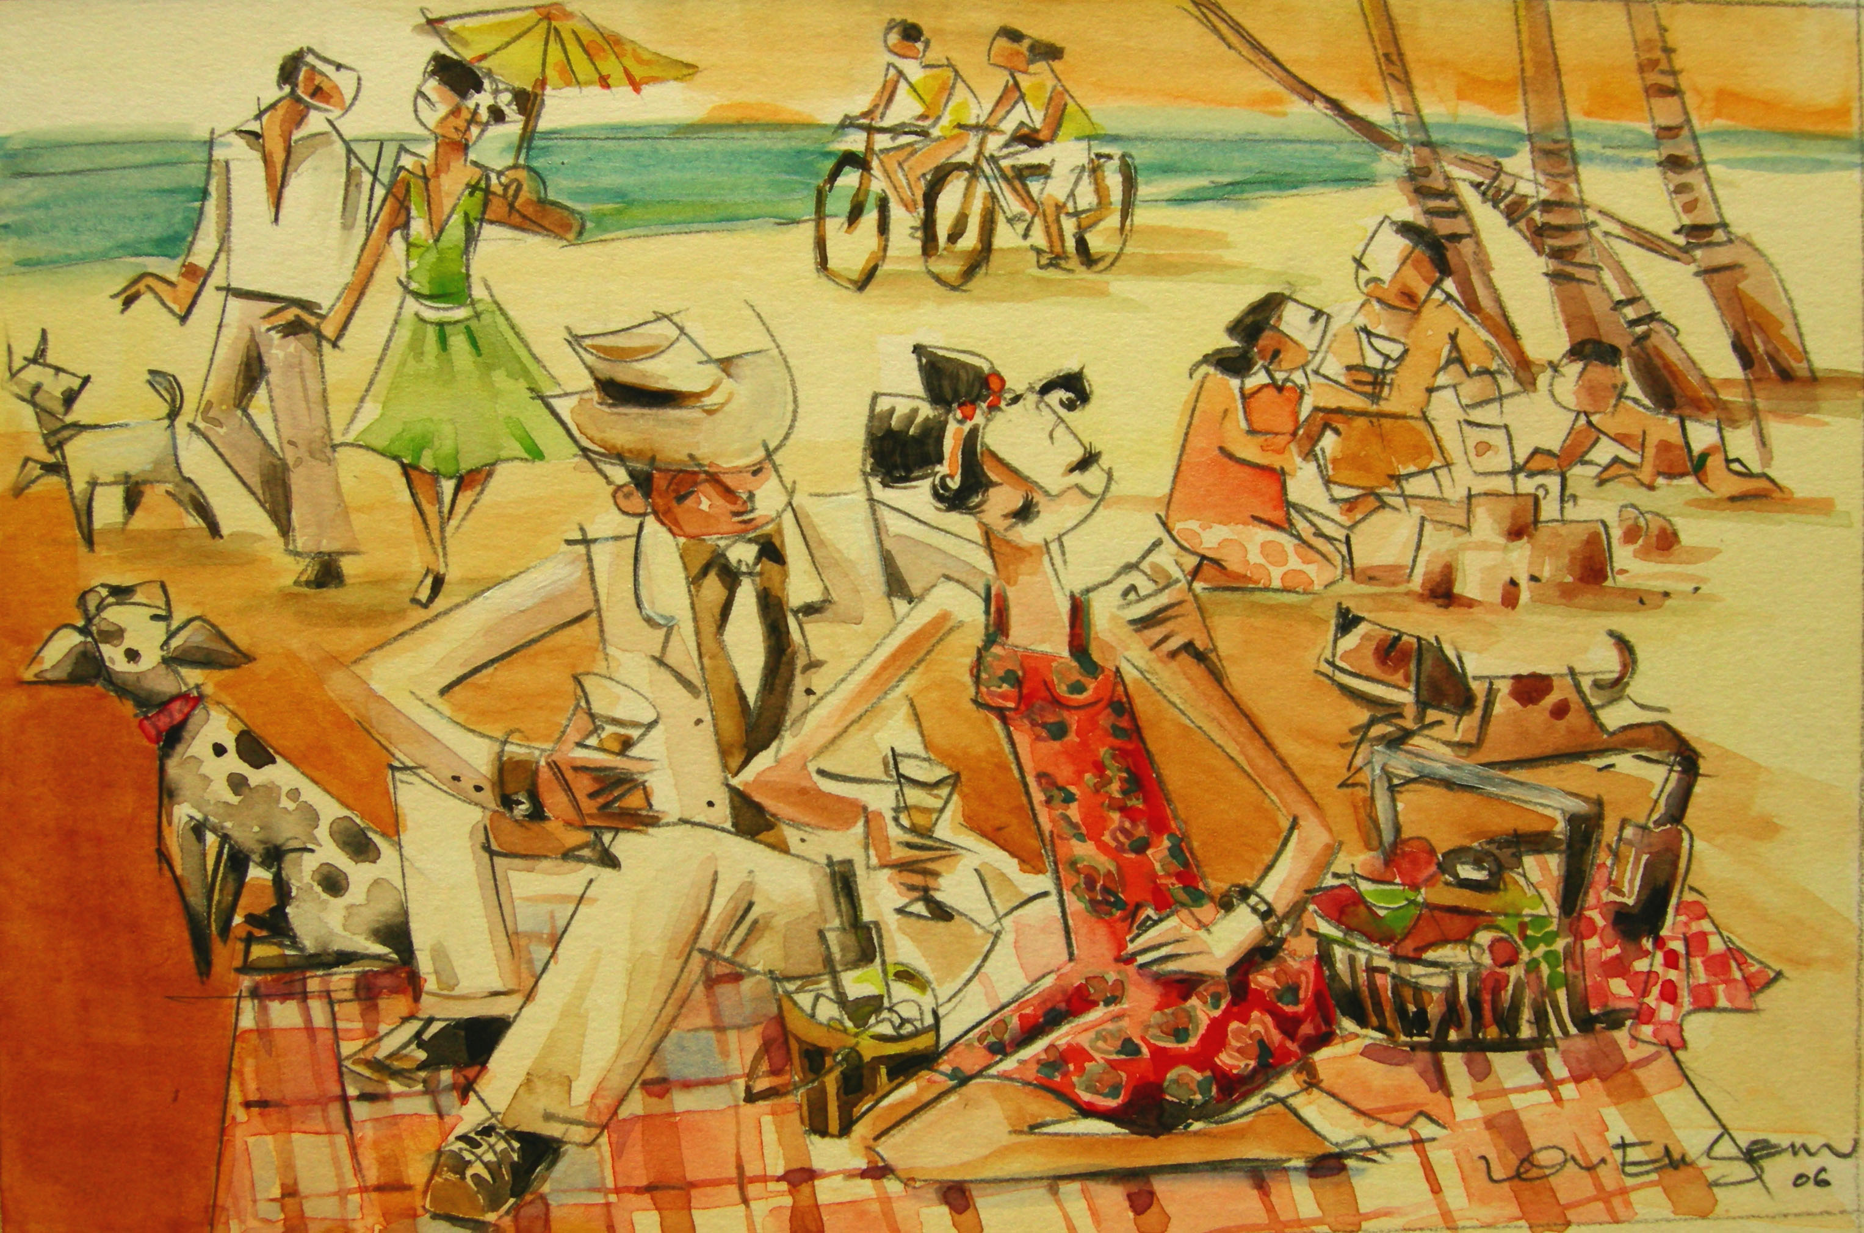

Picnic
On weekends, the Peranakans could be found at their beach bungalows, having family picnics.

